vxdjkvb


Imam Mohammed Ibn Saud Islamic University

Collage of Computer and Information Sciences

Computer Science Department

**Course:** CS 290

**Instructor:** Dr.Yassin dada

**Section:** 172

**Team:**

Abdulrahman Altamimi: 441016130,

Abdullah Alnahidh: 441015739

Ziyad Altuwaym: 441023320

Dakhilallah alkaltham: 441010847

Fahad Almusllam: 441013997

Software engineeriing project PHase 1 and 2

# **Table of Contents**

Table of Contents

**Table of Contents** 1

**Definition** 3

**Introduction** 4

**Project Description** 5

**The Purpose of The Documents** 6

**Main Goals and Project Objectives** 6

**Challenges** 7

**Team Members** 8

**Project expected timeline** 11

**Software Development Lifecycle (SDLC)** 12

**We choose the Scrum Method!** 13

**When we use Scrum model** 13

**Agile development Cycle** 14

**Scrum Method** 15

**Detailed plan** 17

**Project Functional and Non-Functional Requirements** 18

**Requirement Processes and Activities** 19

**Use Case:** 20

**Stakeholders’ Benefits from the Project** 21

**Functional Requirements** 22

**Non-Functional Requirements** 23

**Business Requirements Specifications (BRS)** 25

**Software Requirements Specifications (SRS)** 28

**Graphical Modules** 29

**Effort/Time Estimation** 31

**Intended Technology** 32

**Requirements Expectations Plan and Timeline** 33

**End of Phase 1** 34

**System Model Requirments Design** 35

**Sequence Diagram** 36

**State Diagram** 37

**Class Diagram** 38

**Acchitectural design and pattren** 39

**Model View Controller (MVC)** 40

**Why MVC?** 40

**MVC Components** 41

**Project Prototype** 42

**Scrum Method Logs and schedules** 46

**End of Phase 2** 50

|  |  |
| --- | --- |
| **Definition** | |
| DMD | Daycare Management department |
| SDLC | Software development Cycle |
| BRS | Business Requirements Specifications |
| SRS | Software Requirements Specifications |
| Scrum | Software Development Process Method |
| Scrum Master | Project Leader |
| Faculty | Daycare center in IMAM Mohammed ibn Saudi Islamic University |
| Services | Means all services that must be performed or carried out by the contractor according to the scope of work |

# **Introduction**

Through This project which has been requested by Daycare Management Department (DMD) is set to improve and digitalize the DMD old paper-based work system to a new web-based system. The new system will be more accessible and efficient and will deliver the needs to the child’s parent and the staff involved to improve the workflow and communication in the DMD which going to make the process such as the registration and the payment easier for all whom is concerned. For example, the parents will be able to register their children in their living room without attending in the DMD faculty!

# **Project Description**

## **The Purpose of The Documents**

The purpose of this document is to provide a detailed description of what is going to be implemented in straight forward method. This document is meant to be as a guide to the stakeholders for the step that has been taken and represented in the clearest way possible.

## **Main Goals and Project Objectives**

**•** New Front for the DMD

With a new weep-set future customers can get all the information they need about the service and attract more people who need this service.

• new front for the DMD

With a new weep-set future customers can get all the information they need about the service and attract more people who need this service.

• online services

Provide the customer with the opportunity to register for the service and complete their payment online without attending the facility.

• easy access file archive

With all the document digitalized a good archive system is necessary for fast access to any kind of information the staff might need.

• Follow Up the Workflow and the Timeline

Provide the DMD management with advance attendance schedule which keep track of arrival and depart of the kids.

• Simplify the communication

Develop fast and trusted communication channel between the staff too share necessary documents and between the DMD and the families which can I accept request and complains.

## **Challenges**

* Time limitation

With the delay of the green line to start the project our ideas of what this project could be was cut short and with the short new semester caused an interlap with more midterms more frequent.

* No Graphic designing experiences

As aspiring software programmers, we lack a graphic design experience which will tack a long time to learn.

* Lack of Details

Understanding the procedures and the exact process of the establishment was challenging to a business we were unfamiliar with.

with a team steel learning the ways of a program developers finding the right answers took a long time and effort

* Lack of experience

This is the first big project for a student of our level so the team was unfamiliar with the format which it should be done

With addition that:

* Reach problems and limited engagement with the stakeholders
* Misunderstanding in several points in the project

## **Team Members**

|  |  |  |  |  |  |
| --- | --- | --- | --- | --- | --- |
| Members | | | | | |
|  | Abdullah  Alnahidh | Abdulrahman  Altamimi | Ziyad  Altuwaym | Fahad  Almusllam | Dakhilallah Alkaltham |
| Scrum Master | Checkmark with solid fill |  |  |  |  |
| Requirements Analysis |  | Checkmark with solid fill | Checkmark with solid fill | Checkmark with solid fill | Checkmark with solid fill |
| Development  UI/UX | Checkmark with solid fill | Checkmark with solid fill | Checkmark with solid fill | Checkmark with solid fill |  |
| Designing | Checkmark with solid fill |  | Checkmark with solid fill |  | Checkmark with solid fill |
| Researching |  | Checkmark with solid fill |  | Checkmark with solid fill |  |
| Creativity | Checkmark with solid fill |  |  | Checkmark with solid fill | Checkmark with solid fill |
| Testing |  | Checkmark with solid fill | Checkmark with solid fill |  |  |

|  |  |  |  |  |
| --- | --- | --- | --- | --- |
| Name/Age | Abdullah Alnahidh | | | 22 |
| Background | Computer Science student at Computer and Information Science College in Alimam Mohammed ibn Saud Islamic University. Worked in several small projects during study period in the college. | | | |
| Programming  languages | Python | Java | HTML | C |

|  |  |  |  |  |
| --- | --- | --- | --- | --- |
| Name/Age | Abdulrahman Altamimi | | 22 | |
| Background | A CS Student passionate about Programming-Coding aiming to major in Software Development and interested in Artificial Intelligence and Games Development. | | | |
| Programming  languages | Python | Java | | C |

|  |  |  |  |  |
| --- | --- | --- | --- | --- |
| Name/Age | Dakhilallah Alkaltham | | 22 | |
| Background | CS Student interested in Cyber Security and safe programming. | | | |
| Programming  languages | HTML | Java | | C |

|  |  |  |  |  |
| --- | --- | --- | --- | --- |
| Name/Age | Ziyad Altuwaym | | 22 | |
| Background | CS Student at ImamU, interested in app development and game experience and development and combining it with AI. | | | |
| Programming  languages | Java | HTML | | Swift |

|  |  |  |  |
| --- | --- | --- | --- |
| Name/Age | Fahad Almusllam | | 22 |
| Background | Computer Science Student at IMISIU, Interested in artificial Intelligence and cloud computing. | | |
| Programming  languages | Java | C | |

## **Project expected timeline**

# **Software Development Lifecycle (SDLC)**

## **We choose the Scrum Method!**

Scrum refers to an agile development method for developing software that is iterative and incremental. Scrum is an adaptable, fast, flexible, and effective agile framework that delivers value to the customer throughout the entire project development process. The primary objective of Scrum is to satisfy the customer’s need through an environment of transparency in communication, collective responsibility, and continuous progress. It starts with a general idea of what needs to be built (product backlog) by elaborating what the product owner wants.

## **When we use Scrum model**

* This model is flexible and easy to edit and less costly to change requirements
* Adaptable, Fast, and effective framework
* Quality improvement
* Satisfaction for both the customer and the employee
* It helps for creativity and innovation
* When we use the scrum model, it will help to generate working software quicker during the lifecycle
* It is easier for testing and debugging
* In this model we can get the stakeholders feedbacks for each cycle
* Risks are easy to manage
* Errors can easily be determined
* Easy to manage each iteration

# **Agile development Cycle**

* Planning

Determine the team skills and distribute the work between the team and make an initial view about what’s going and how to be done in the project.

* Requirements

In this phase we will start identifying the requirements then gather it and understand it, then started to by analyzed. The requirements include the functional and the non-function ones.

* Design

During this phase the system design functionality and development method done by the team successfully.

* Implementation

Is the addition of a new function based on the request of the customer and the most urgent functionality.

* Testing

In this phase we test our system including the performance for all the functions and check the software with customer to make sure it is working and satisfy the customer’s needs.

* Evaluation

Is the process which the customer validates of the function being added and gave feedback to the developer

## **Scrum Method**

* Product Owner

In general. The lead User of the System, Ensure the success of the system, fully understood the user’s requirements, define the user’s story and responsible for creating, managing, and optimizing the product backlog.

* Scrum Master

Basically, the leader of the team. The Scrum master serve, guide, support the team. Protect the team for outside distractions communicate with the product owner. Plan the sprint. Leading the daily meetings.

* User Story

User story is the tool that used to provide description of the features of the software from the end user perspective. in other way the user story includes sentences in simple language that describe the desired outcomes they don’t include the details or the requirement the details and the requirements added later in the back log. The purpose of it a piece of work will return a value to the costumer. And generally written by the product owner

* Product Backlog

A product backlog is a list of the new features, changes to existing features, bug fixes, details, requirements, user story and infrastructure changes or other activities that a team may deliver to achieve a specific outcome.

* Sprint Backlog

Compiling a sprint backlog gives teams a clear vision of sprint success and provides the opportunity to discuss what’s possible, what needs prioritizing and what may have changed in the strategy since the last sprint.

* Sprint 1-4 Weeks (Agile Development Cycle in Each Sprint!)
* Daily Scrum

Daily scrums are quick meetings held each day at the same time handled by the scrum master and the meeting is for members of the product development team working on a particular sprint. The team collectively reviews the progress made toward achieving the Sprint Goal.

* Sprint Review

A sprint review is an informal meeting held at the end of a sprint, during which the team shows what was accomplished, while the stakeholders provide feedback. It's a collaborative working session rather than a one-sided presentation.

* Retrospective

A retrospective is a meeting held after a product ship to discuss what happened during the product development and release process, with the goal of improving things in the future based on those learnings and conversations.

## **Detailed plan**

Scrum model phases:

Milestone Milestone

Work Breakdown:

|  |  |  |
| --- | --- | --- |
|  | Task description | duration |
| Task 1 | Getting the initial requirements from the costumer and analyzing the requirement | **3 days** |
| Task 2 | Analyzing and understanding the business requirement specification (BRS) | **1 WEEK** |
| Task 3 | Analyzing and understanding the System requirement specification (SRS) | **1 WEEK** |

# **Project Functional and Non-Functional Requirements**

## **Requirement Processes and Activities**

* Requirements elicitation

This process is concerned about identifying researching, discovering, and communicating and collaborating with the project owner to determine the project’s needs and requirements

* Requirements Analysis

Requirements analysis we can say it’s the process that we use it to understand and determining the requirements by dividing the requirements into functional and non-functional requirements categories, then determine the accessibility of each user and then give priority to each requirement

* Requirements Validation

Requirements validation is the process of checking that requirement if it’s what actually the customer wants. Requirements validation is important because if the requirements have an error or not validated this well need a lot of modifications and rework to get to the successive stage. We should check if any Requirements are conflicted with each other, The requirements should be complete and achievable

* Requirements Management

Requirements management is the process of understanding and controlling changes to system requirements. There is more than one reason for the system requirement to change. Such as when the business and technical of the system always changes after installation. And new hardware may be introduced for example and the people who pay for a system and the users of that system are rarely the same people. Large systems usually have a diverse user community, with many users having different requirements and priorities and for that the requirements may change several times.

## **Use Case:**

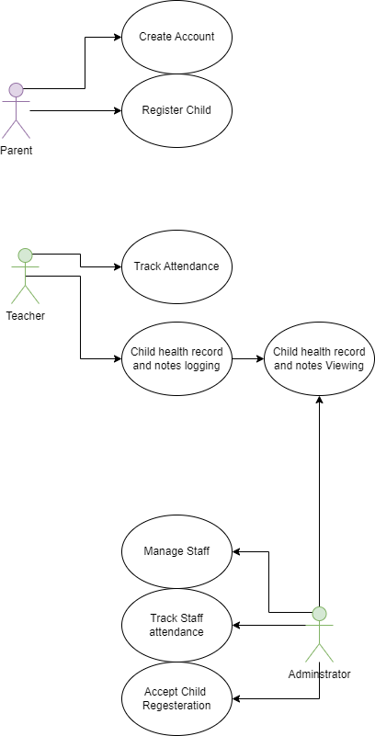

## **Stakeholders’ Benefits from the Project**

* Parent

the parent will benefit greatly from the regeneration of his child and the easy payment of the fee to the fast communication with the staff

* Teacher

the teacher will access the serves on daily basis, and he is the biggest beneficial; the easy-to-use attendance system and trusted tracking system of kids check in and out of the establishment and the comprehensive document filing serves

* Administrator

the administrator in charge of conforming payment and accept the register and document archive and communicate with the parent

## **Functional Requirements**

|  |  |
| --- | --- |
| F/Priority(1-3) | Functional Requirements |
| F.1/1 | Login page. |
| F.2/1 | Home page |
| F.3/1 | Each child should have his own personal page created by the parent to view his information (childbirth date, contact number, child health condition). |
| F.4/3 | Each employee has a contact page and account |
| F.5/2 | Enrollment periods annunciation |
| F.6/1 | It should enable the parents to fill out their children’s information and submit them. |
| F.7/2 | DMD conditions agreement |
| F.8/3 | E-mail service |
| F.9/3 | Communication options |
| F.10/2 | Parents information so can the employee be able to reach them. |
| F.11/1 | Data updating |
| F.12/2 | SMS service |
| F.13/1 | Well designed and consider UX |
| F.14/1 | Data base |
| F.15/2 | Flexibility for modification |
| F.16/1 | Support Dates, time zone, desired calendar in the application and procedures |
| F.17/1 | Child application agree/refuse |
| F.18/2 | Child record and health condition logging and reviewing |
| F.19/3 | Upload feature to save documents in the database |
| F.20/3 | Accounts and Profiles features |

## **Non-Functional Requirements**

|  |  |
| --- | --- |
| NF | Non-Functional Requirements |
| NF.1 | Performance: The program must run on high ram computer to make sure the software run flawlessly (response time, speed of moving between pages, brows refresh time) |
| NF.2 | Usability: The software most be clear and simple for any person with no technical background to access any function they may need |
| NF.3 | Security and Privacy: The access permissions of the platform data can only be changed by the system data Administrators (Login clearance, Data protection) |
| NF.5 | Availability: The software most be accessible for the stockholder at any time.  Not being to access at any giving time will delay the staff or compromise the parent trust in the DMD |
| NF.6 | Maintainability: THE SOFTWARE will be maintained to solve any problem may over time |
| NF.7 | Recoverability: The system must obey all the governmental requirements. |
| NF.8 | Quickness: The system shall work quickly. |
| NF.9 | Language: The system must be in Arabic with the possibility to switch to English |
| NF.10 | Regulatory: The system must obey all the governmental requirements |

**BRS and SRS**

## **Business Requirements Specifications (BRS)**

Project Description

Create a website that serves the Daycare staff to make the schedules for the children and digitalize the registration process, more visible and usable than the old paperwork, and includes an announcement system between staff and parents (emails) using electronic schedules that help organize age-room register.

BRS

The BRS will provide a brief description about the business requirements specifications after meeting up with the stake holders and understood their perspectives to draw a clear path for structuring the project.

* digitalize the registration forms and conditions/agreements.

|  |  |
| --- | --- |
| After the Registration and filling and uploading all the required documents the parent must click the accept button for the. | Conditions |
| Agreements |

* The parent should be able to upload Medical Examination report and the child needs report, family card and birth certification and 6x6 child picture.

|  |  |
| --- | --- |
| Parent Must Upload: | Medical Examination report |
| child needs report |
| family card |
| birth certification |
| 6x6 child picture |

* the website should provide registration coordinator account and general supervisor account and Parent/child account.

|  |  |  |
| --- | --- | --- |
| Accounts on the Website | | |
| Registration Coordinator | General Supervisor | Parent/Child |

* University Staff and students have priority for the acceptance.

|  |  |  |
| --- | --- | --- |
| Who is allowed to register their children? |  | Priority |
| The General Public | University Staff and Students |

* the website should be only for registration and administration
* children with chronic disease or mental illness problems cannot be accepted

|  |  |  |
| --- | --- | --- |
| Does the child have a chronic illness, disability, or mental illness? | No | The registration process continues |
| Yes | The registration process terminates, and parent must be informed about reason for the termination: it was one of the conditions that the parents accepted |

* providing building and class scheduling depending on the choice or crowd and dependents on the age of the child

|  |  |  |  |
| --- | --- | --- | --- |
| Child Name: | Age: | Building: | Room: |
| First Name and Last Name | From 1 to 6 | For example: 1B | For Example: 123 |

* providing the agreement signature form to download then print for the parent to provide when attending to the Daycare center for the payment (option to save the parent time) the parents also can attend to the daycare and have the form there.
* provide the prices and discount for university staff and students

|  |  |  |
| --- | --- | --- |
| Prices? |  | Discount |
| The General Public | University Staff and Students |
| For example: 2222SR per semester | For example: 1111SR per semester |

* all children files for the previous year should be deleted in the beginning of every new academic year

Year ends

Year Started

## **Software Requirements Specifications (SRS)**

**SRS**

A software requirements specification (SRS) is a document that describes what should the software do and how it will be expected to operate. It is also describing the functionality that product needs to satisfy all stakeholders needs.

**Purpose of an SRS**

An SRS forms the basis of an organization’s entire project. It sets out the framework that all the development teams will follow. It provides critical information to all the teams, including development, operations, quality assurance and maintenance, ensuring the teams agreement.

Features of an SRS

* Correct:

should accurately reflect product functionality and specification.

* Complete:

should contain all the features requested by a client.

* Verifiable:

an SRS is verifiable only if every stated requirement can be verified. A requirement is verifiable if there is some method to quantifiably measure whether the final software meets that requirement.

* Modifiable:

an SRS must clearly identify each requirement. If there are any changes, the specific requirements and the dependent ones can be modified without effecting the other ones.

* Traceable:

an SRS is traceable if the origin of each of its requirements is clear and if it makes it easy to reference each requirement in future development.

## **Graphical Modules**

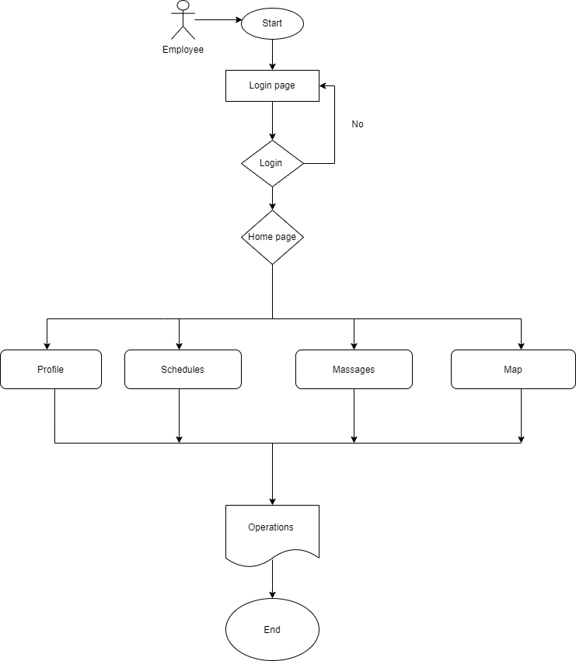

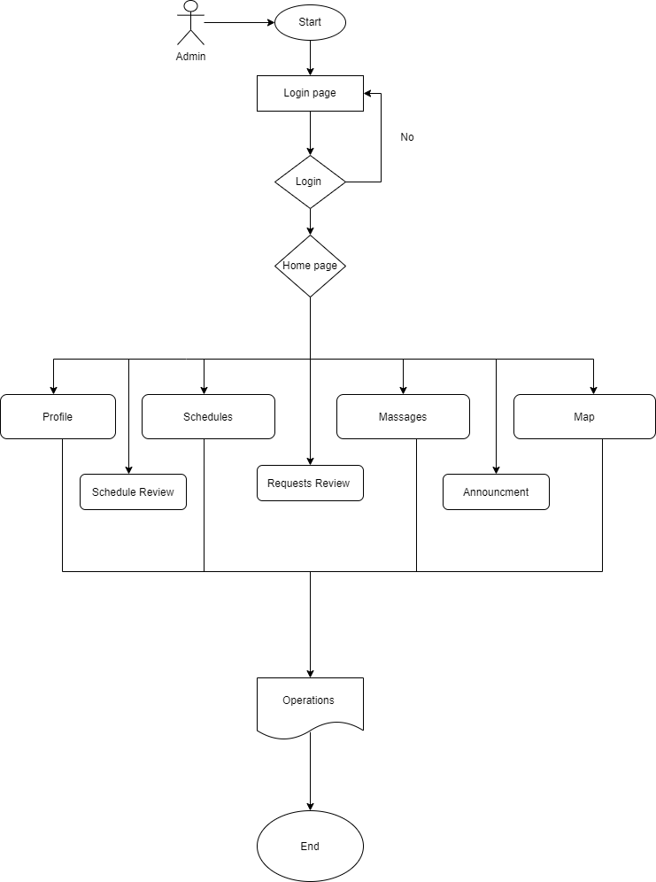

# **Effort/Time Estimation**

|  |  |
| --- | --- |
| Requirement | Estimate(1-5) |
| Home page | 1 |
| Payment Methods | 5 |
| E-mail service | 4 |
| Communication options | 3 |
| Attendance monitoring | 2 |
| Data base | 5 |
| Child application | 3 |
| Child record and health condition | 3 |
| DMD conditions agreement | 2 |
| Each employee has a contact page and account | 2 |
| Each child should have his own personal page | 2 |

# **Intended Technology**

|  |  |
| --- | --- |
| Programming Languages | HTML and Java script |
| Database | mySQL |
| Web Design | framework CSS |

## **Requirements Expectations Plan and Timeline**

Will be depending on the priority of the function

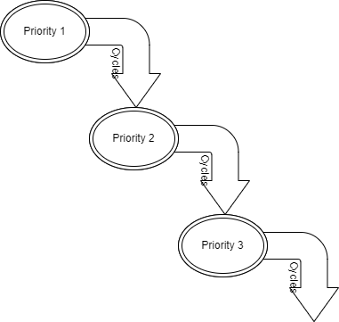

# **End of Phase 1**

# **System Model Requirments Design**

## **Sequence Diagram**

## **State Diagram**

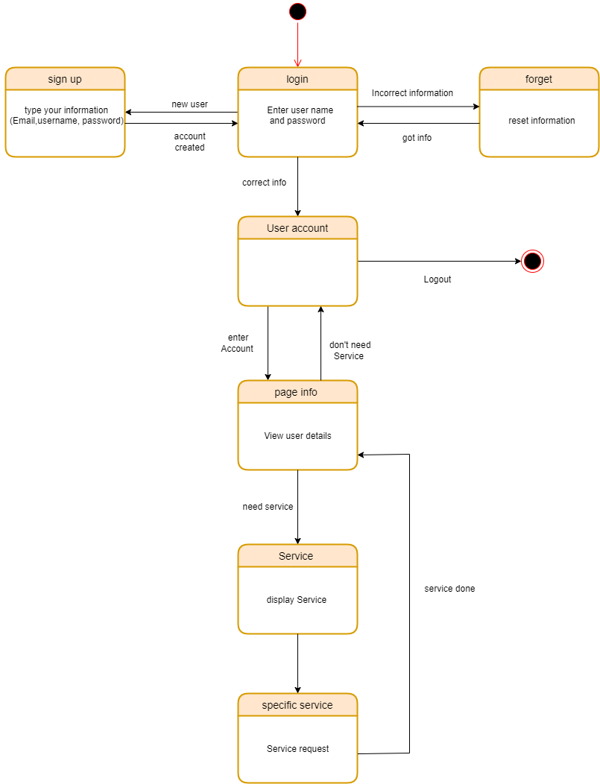

## **Class Diagram**

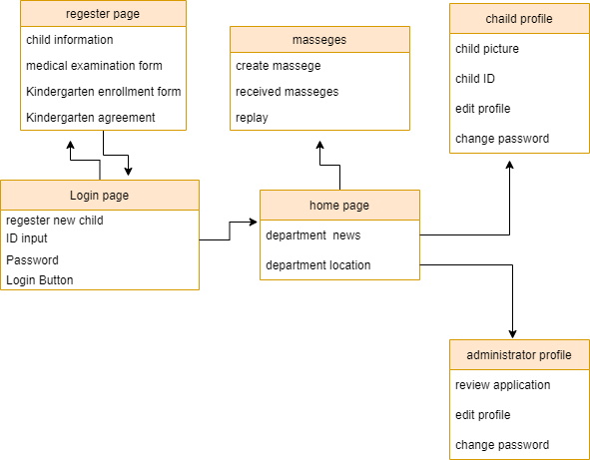

# **Acchitectural design and pattren**

## **Model View Controller (MVC)**

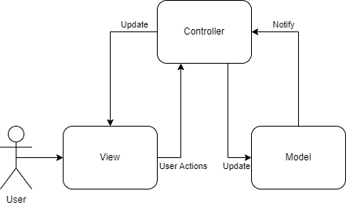

## **Why MVC?**

First of all, what is MVC? It is one of the highest popularity software architectures at the moment.

And it contains three components

* The Model
* The View
* The Controller

Every single component has a specific purpose and does a specific aspect, and it was built for at originally.

Ok now why the MVC? Good question:

It will make our work so much easier such as if we want to change or modify or build from the beginning. how? Because it separate the front end and the backend code into to individual components

Also its compatible to our development process method the scrum method because it is support rapid development and give us the ability to provide multiple views.

## **MVC Components**

**The Model**: This component provides all the data-related logic that the user interacts with. It could represent the data that is transferred between the View and Controller parts, or it could represent any other data related to business logic.

**The View**: Any presentation of an application View contains the interface (UI) and It is defined by the user such as user choose the screens, keyboards, text boxes, dropdowns and other thinks It is also the way through which a user interacts with an application or a website.

**The Controller**: This part of the MVC is the bridge between the view and the model and the customer; it controls the passage of the data that the customer asked for from the model to the view and gives appropriate respond for the browser request.

# **Project Prototype**

**Starting Page:**

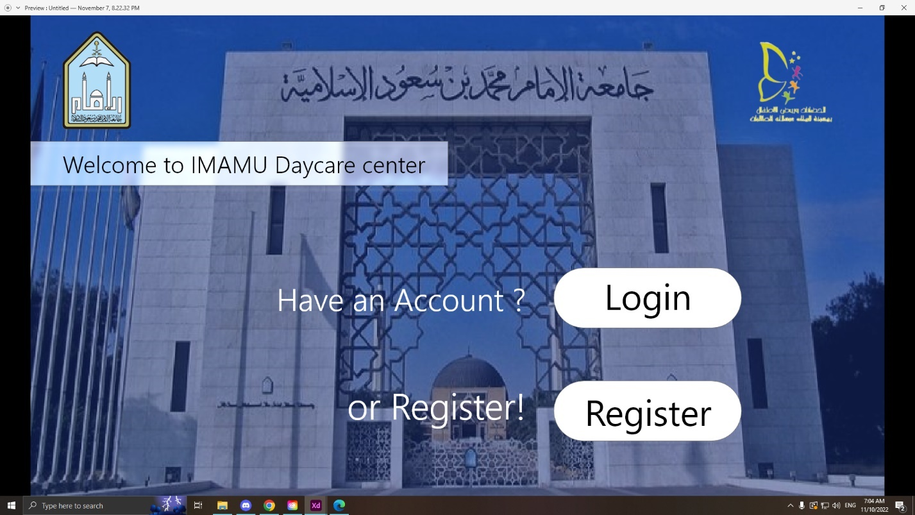

**Login Page:**

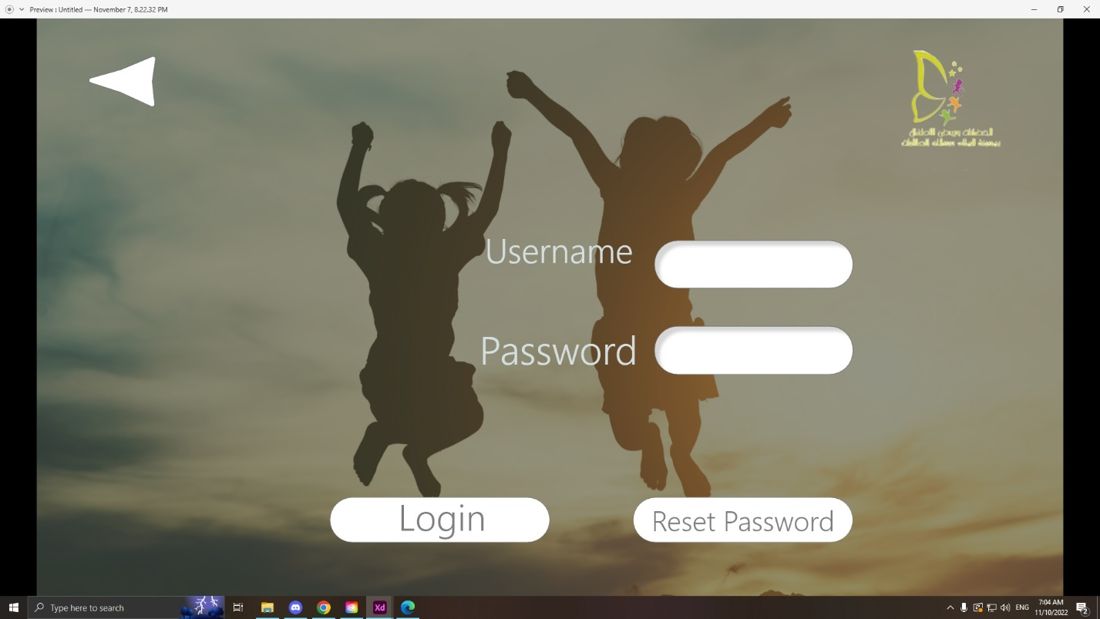

**Register Page:**

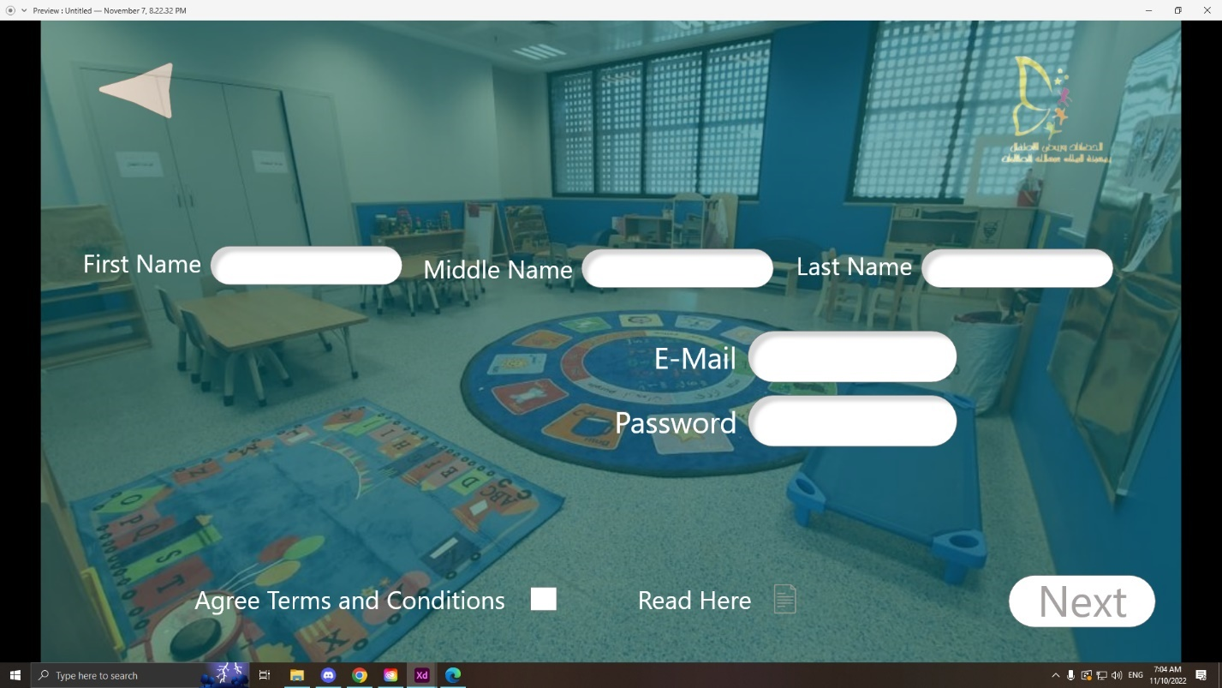

**When the next button is pressed there will be the completion of the procedures such as the child info, Daycare center information requirements etc.**

**General Supervisor / Registration Coordinator / Parent home page:**

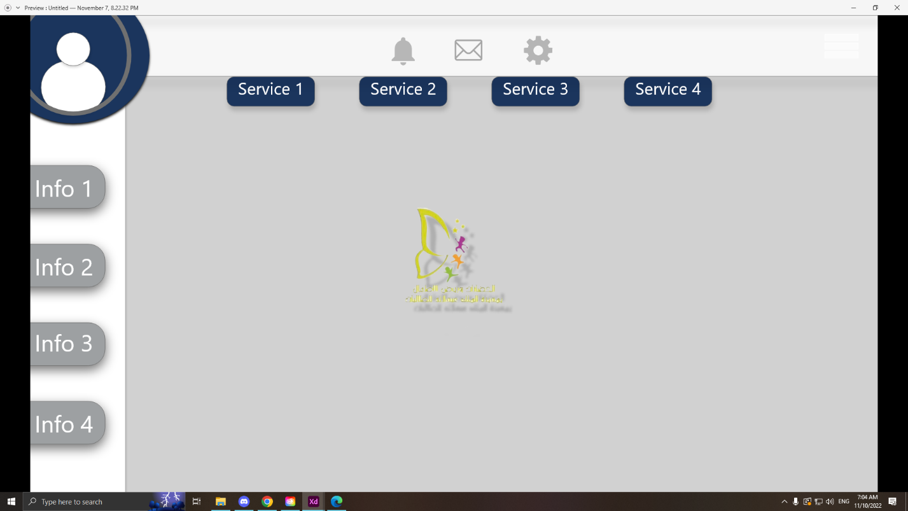

**Each actor has the same home page, the same design etc., but the deference is the permissions and the services they expected to evoke from a specific actor.**

# **Scrum Method Logs and schedules**

**Product Backlog:**

|  |  |
| --- | --- |
| Requirement | Estimate (1-5) |
| Home page | 1 |
| Payment Methods | 5 |
| E-mail service | 4 |
| Communication options | 3 |
| Attendance monitoring | 2 |
| Data base | 5 |
| Child application | 3 |
| Child record and health condition | 3 |
| DMD conditions agreement | 2 |
| Each employee has a contact page and account | 2 |
| Each child should have his own personal page | 2 |

**Sprint Backlog:**

** Week 1:**

**Daily meeting**

**Week 2:**



**Daily meeting**

**Week 3**



**Daily meeting**

# **End of Phase 2**